**Configure a Servlet in Eclipse IDE.**

**Step 1: Creating a dynamic web project.**

* Open Eclipse
* Go to the **File** menu. Choose **New->Dynamic Web Project**
* Enter the project name as **FirstServlet**. Click on **Next**
* Enter nothing in the next screen and click on **Next**
* Check the checkbox **Generate web.xml deployment descriptor** and click on **Finish**
* This will create the project files in the Project Explorer

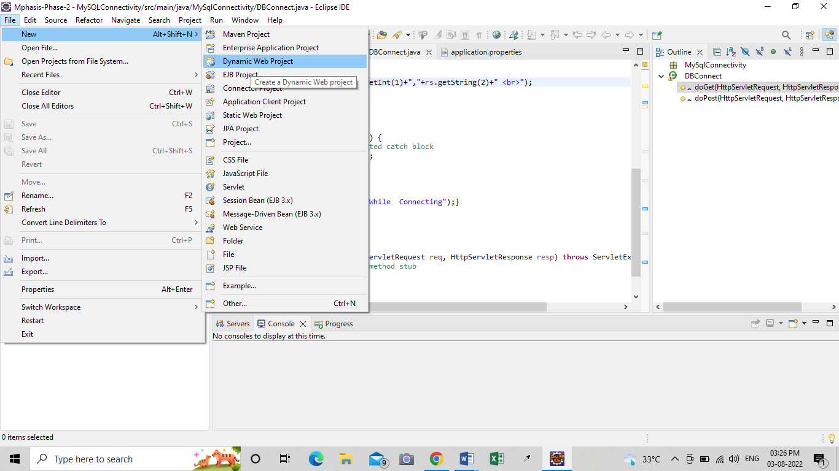

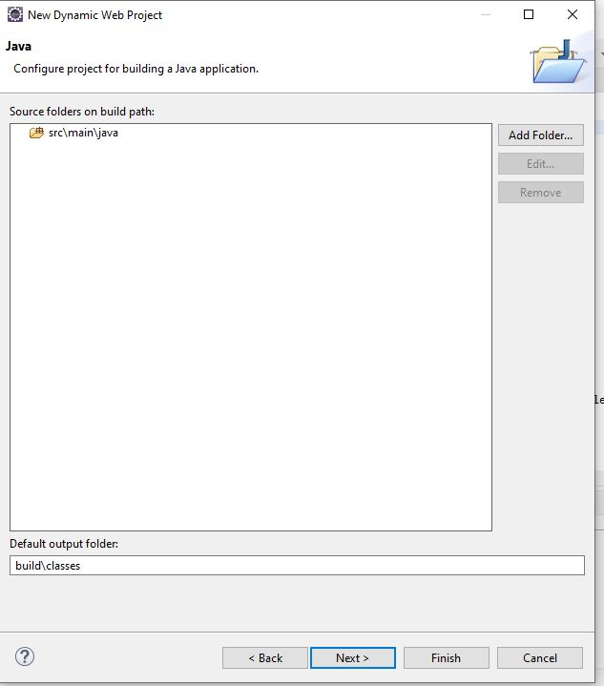

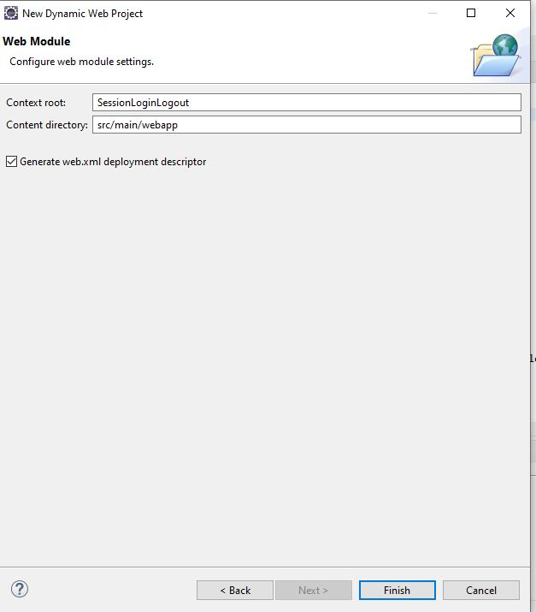

**Step 2: Create a servlet.**

* In the Project Explorer, expand **ServletConcept->Java Resources**
* Right click on **src** and choose **New->Servlet**
* In **Class Name,** enter **FirstServlet** and click on **Finish**

